BED 106 — BUSINESS ANALYTICS
Mini Business Analytics Capstone Project
Checkpoint 3: BI Dashboard Development
Semi-Final Period — Weeks 10–13
Project Title: RetailPulse — Poblacion Grocery Mart
Business Domain: Retail & Sales Analytics
Group: Arowana Kings
Group Members and Roles:
Member Name | Role
Angel Frederick Paredes | Lead Developer / Project Lead
Jeeruz Marl Tabar | Research Support
Luke Kibry Jao | Testing Support
Clein Lord Will Surigao | Documentation Review
Instructor: Jessie A. Melendres
Talibon Polytechnic College
A.Y. 2026–2027 | 1st Semester

Task 3.1 — Dashboard Design Blueprint
The dashboard will be built in Power BI Desktop, using the same poblacion_grocery_mart data behind Checkpoints 1 and 2, plus the product segmentation from Task 3.3 below. It is organized into three pages, each with a distinct analytical purpose.

Page 1 — Executive Summary
Purpose: Give a store owner a 5-second read on overall performance — the four numbers and two charts that matter most, before drilling into any detail.
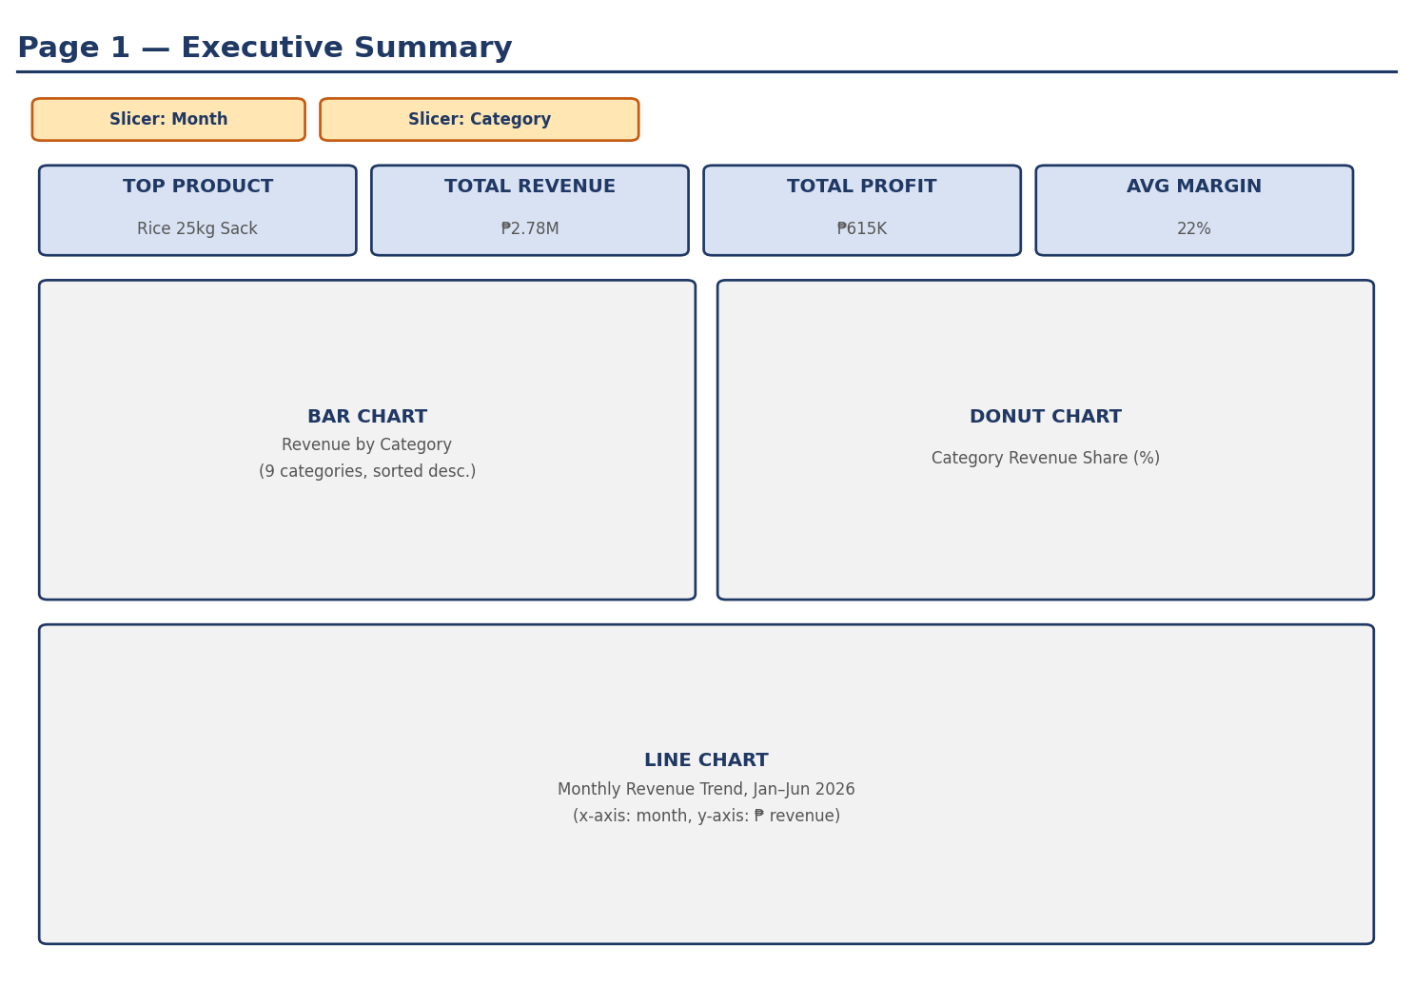
Figure — Wireframe, Dashboard Page 1
Planned visuals: 4 KPI cards (Top Product, Total Revenue, Total Profit, Average Margin); a bar chart of revenue by category; a donut chart of category revenue share; a line chart of monthly revenue trend.
Interactive elements: Month slicer and Category slicer, both filtering all visuals on the page.

Page 2 — Trend & Comparison Analysis
Purpose: Let the owner compare performance across time and across categories/products, to spot which categories are pulling their weight and which are not.
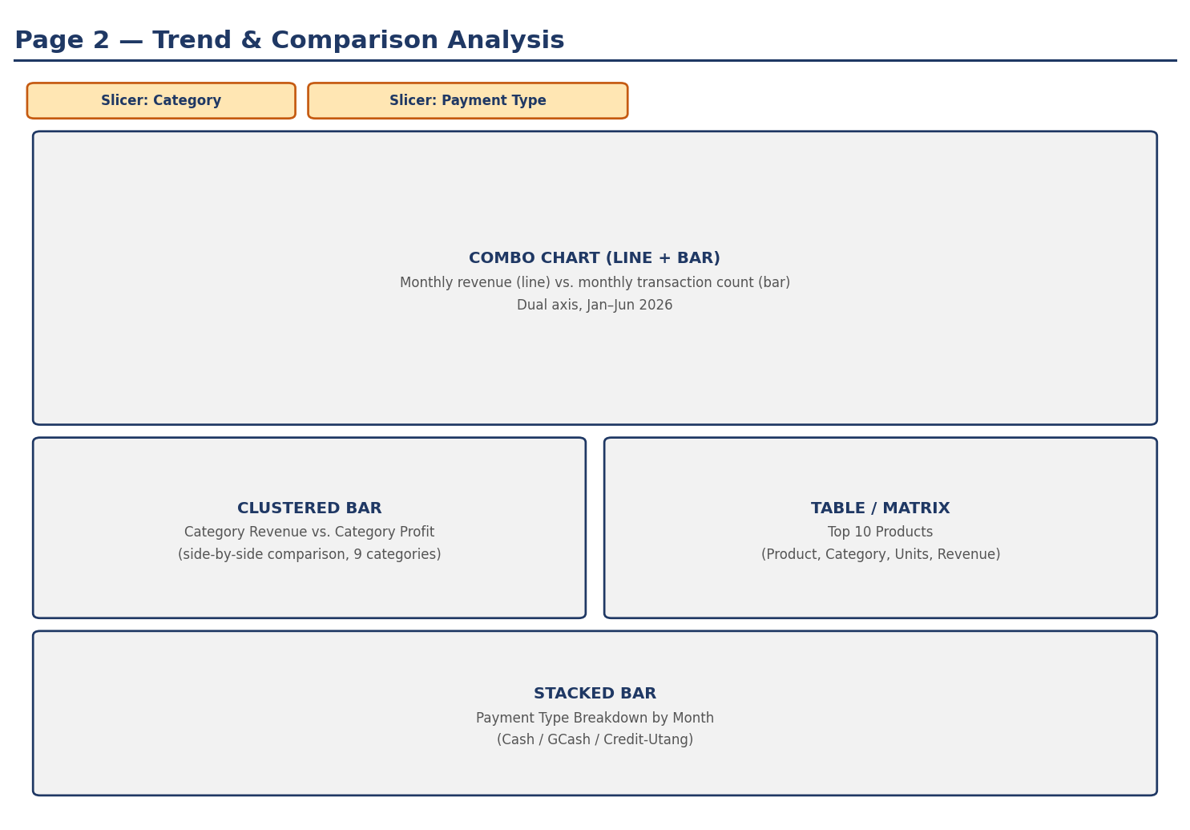
Figure — Wireframe, Dashboard Page 2
Planned visuals: a combo chart (monthly revenue as a line, monthly transaction count as bars, dual axis); a clustered bar comparing category revenue vs. category profit; a table of the top 10 products; a stacked bar of payment type by month.
Interactive elements: Category slicer and Payment Type slicer.

Page 3 — Deep Dive / Segmentation
Purpose: Surface the product segmentation from Task 3.3 so the owner can see which products behave alike, and act on each group differently (e.g., different restocking or promotion strategy per segment).
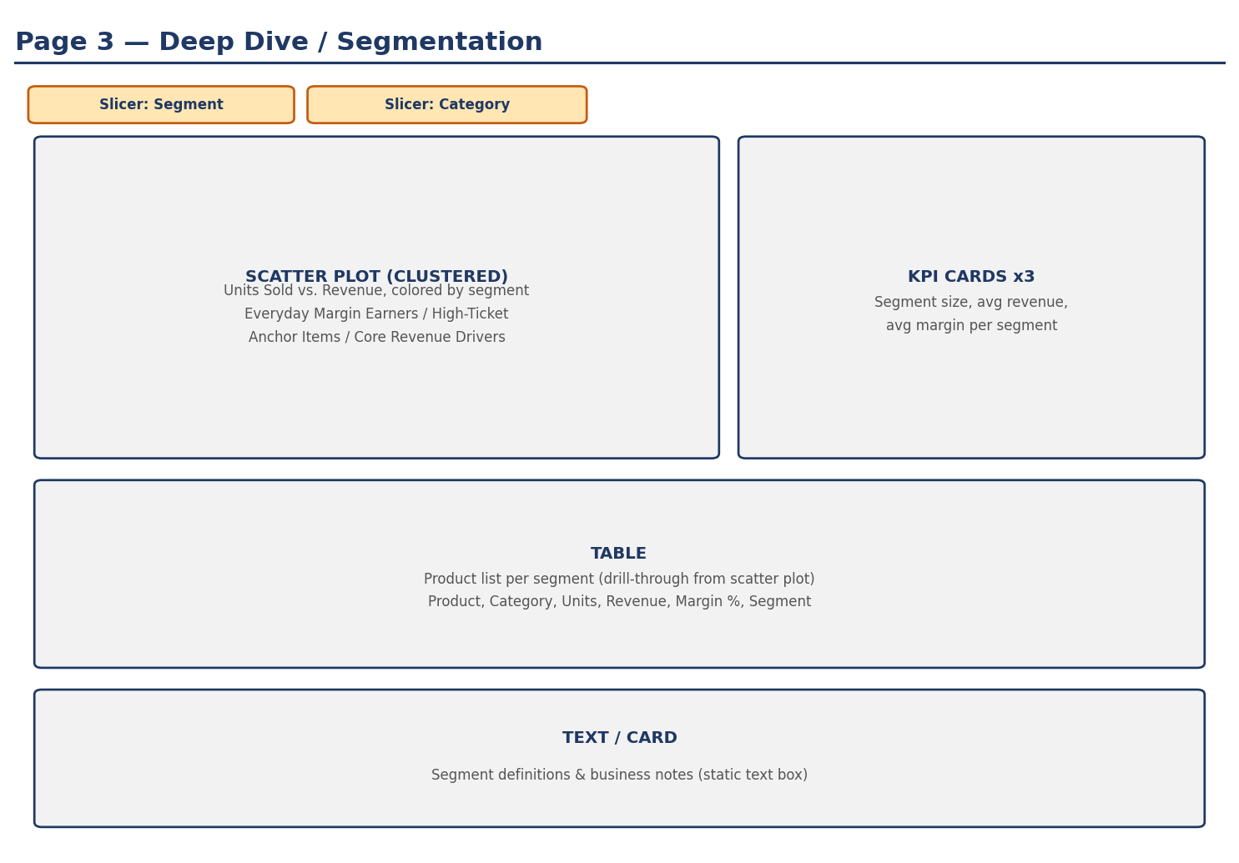
Figure — Wireframe, Dashboard Page 3
Planned visuals: a clustered scatter plot (units sold vs. revenue, colored by segment); 3 KPI cards summarizing each segment; a drill-through table listing every product with its segment; a static text card defining each segment.
Interactive elements: Segment slicer and Category slicer.

Task 3.3 — Data Mining: Product Segmentation
A K-Means clustering (k = 3) was run on all 40 products using three standardized features: total units sold, total revenue, and profit margin percentage, over the 6-month period (January–June 2026). The resulting clusters were labeled based on their statistical profile:
Segment | # Products | Avg. Revenue (₱) | Avg. Units Sold | Avg. Margin %
Everyday Margin Earners | 27 | 25,754 | 750 | 32.9%
High-Ticket Anchor Items | 3 | 324,813 | 377 | 17.4%
Core Revenue Drivers | 10 | 110,982 | 771 | 23.1%
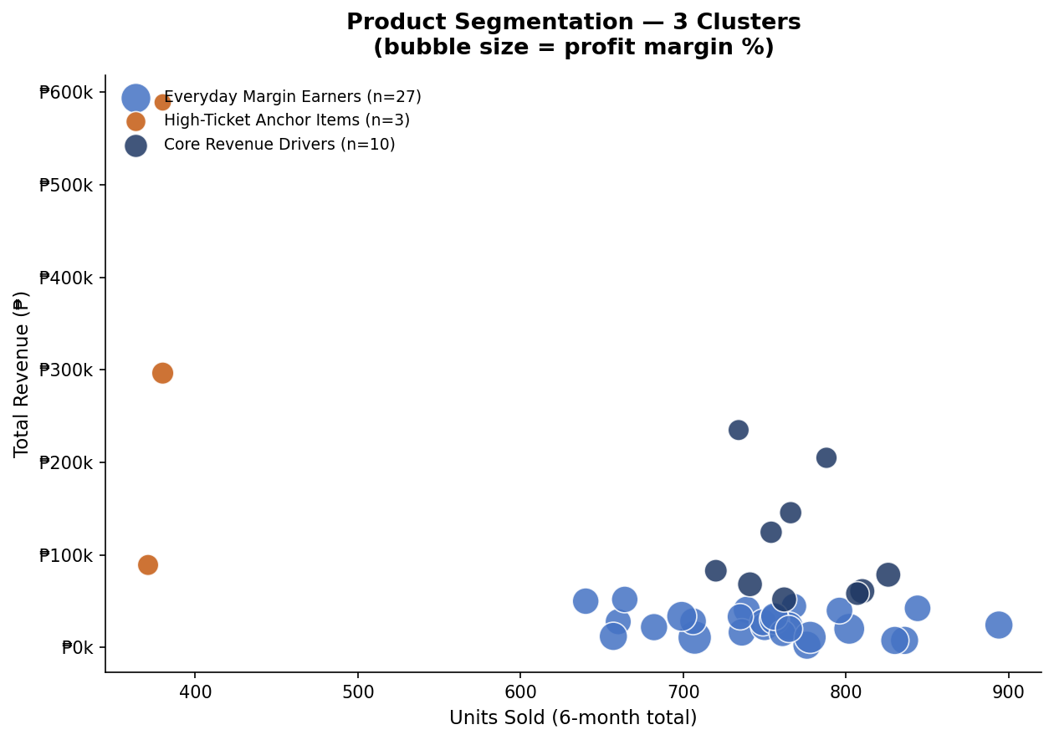
Figure — Product segmentation, units sold vs. total revenue (bubble size = profit margin %)
Segment profiles (from the data):
• Everyday Margin Earners (27 products) — moderate, steady sellers with the highest average profit margin of the three segments. Includes most snacks, personal care, condiments, and household items.
• High-Ticket Anchor Items (3 products) — Rice 25kg Sack, San Miguel Beer (case), and Eggs (tray of 30). Sold in the fewest units but generate the highest revenue per unit, at the lowest average margin of the three segments.
• Core Revenue Drivers (10 products) — high units sold and high revenue, at a mid-range margin. Includes Dinorado/Sinandomeng Rice, Purefoods Hotdog, Frozen Galunggong, and other high-frequency staples.
Each segment calls for a different playbook. Everyday Margin Earners are our most profitable products per peso of sales, so they're the best candidates for cross-selling, bundling, and modest markups — losing a sale here barely dents revenue, but they quietly carry the store's overall margin, so they should never be allowed to go out of stock. High-Ticket Anchor Items are the opposite: only 3 products, but each one is a big-ticket purchase that customers plan around, so keeping Rice 25kg Sack, San Miguel Beer, and Eggs reliably in stock matters far more than trying to raise their thin margins — a stockout on any of these three does more damage to total revenue than a stockout on ten Everyday Margin Earners combined. Core Revenue Drivers sit in the middle and function as the store's steady backbone — high-frequency staples like rice and hotdogs that customers buy every visit — so they need consistent restocking and stable pricing rather than aggressive promotion, since their volume is already reliable and the goal is simply not to disrupt it.

